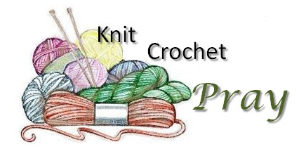
Share the Light - Prayer Shawl Ministry

"For you created my inmost being; you knit me together in my mothers' womb. I praise you because I am fearfully and wonderfully made; your works are wonderful, I know that full well." Psalm 139:14-15

Our Share the Light Ministry is an organization with our Philoptochos designed to reach out to our church family to provide the light of God's love through companionship, caring, help and support by visits, cards and phone calls.

As part of The Share the Light Ministry, we are looking for individuals that can knit, crochet, or are willing to learn, to join us for a new Share the Light - Prayer Shawl Ministry. A Prayer Shawl Ministry creates prayer shawls for those who are in need of comfort. Members of the Prayer Shawl Ministry knit, crochet or sew the shawls as they pray for those who receive the shawls. Prayers are directed to God to bless the work of our hands and to heal and bless those who receive our shawls. This ministry is a way to bless others while those making the shawls receive the blessings of an enriched prayer life. The shawl is a tangible way for the person receiving the shawl to feel the warmth and love of our community and the embrace of God's comfort and healing, compassion and peace.

If you are interested in being part of a Prayer Shawl Ministry, please contact:
Pam Toundas at pandbtoundas@Hotmail.com or the Church Office

If you know of someone that is in need of the comfort of a Prayer Shawl please provide their name to the Church Office.

A Prayer Shawl ministry is undertaken as a gift and a blessing to those in need and as such the time, talent and materials needed to make a shawl are all donated. If you'd like to donate supplies to commission a shawl please let us know.

